Order Of Service

Singing: Psalm 65—CW page 89

Reading: Psalm 130

Opening Hymn: TLH 497

Reading: James 1:19-27

Request Hymn: CW Supplement 702

Reading: Luke 18:18-30

Sermon Hymn: TLH 352

Sermon Text: Song Of Solomon 1:13

A Bundle of Myrrh

Prayer

The Apostles’ Creed, TLH page 12

Holy Communion

The Lord's Prayer

The Blessing

Closing Hymn: TLH 52

* * * * * * * * * * *

Koinonia Hour
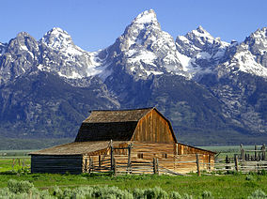

King of Creation

Water
Of
Life

6 September 2015

W A T E R O F L I F E

Independent Christian Church—Conservative Lutheran Doctrine

Worship Service: 9:30 a.m. Bible Study: 10:45 a.m.

Larry Cooper, Pastor E-Mail address:
111 N. Ridge Road lcooper@wateroflife.cc
Coon Valley, WI 54623 Web Site:
Phone: (608) 452-2105 www.wateroflife.cc

* * * * * * * * * * * * * * * * * * * * * * * * * * *

Sermon Text: Song of Solomon 1:13

A Bundle of Myrrh

* * * * * * * * * * * * * * * * * * * * * * * * * * *

13. A bundle of myrrh is my well-beloved unto me; he shall lie all night betwixt my breasts.

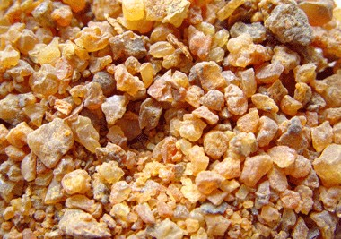

Myrrh Incense
Even the ears of the littlest ones in our congregation perk up at the mention of myrrh. And for all of us, the first thing we think of would be the words of Matthew 2:11—“And when they were come into the house, they saw the young child with Mary his mother, and fell down, and worshipped him: and when they had opened their treasures, they presented unto him gifts; gold, and frankincense, and myrrh.”

In verse 12 of Song of Solomon chapter 1 the Bride presents to her Husband/King her spikenard sending forth a pleasant smell. Now here in verse 13 the Bridegroom presents himself to his Bride as “a bundle of myrrh.”

Again, we are standing here on resurrection ground. And these verses are comforting to us beyond words.

Let’s pray for the guidance of the Holy Spirit, and ponder these precious words which He has for us.

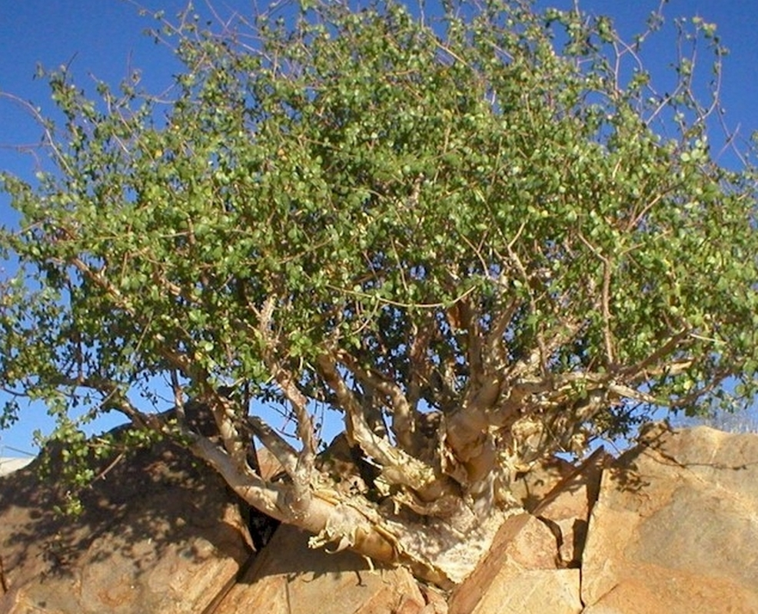

Myrrh Tree

